Name: ____________________________________#___________Date:___________________
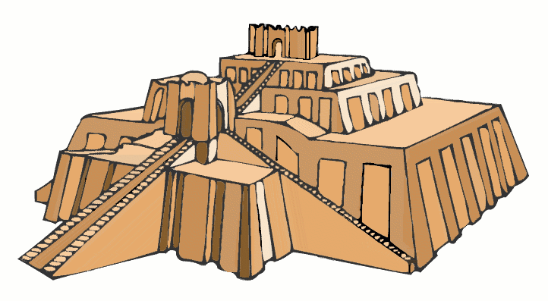
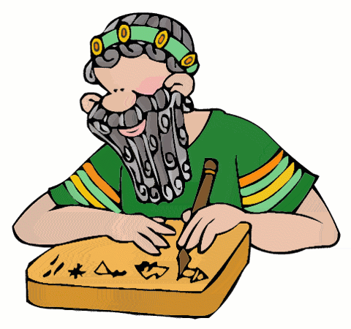
Mesopotamia Magazine

Due Date: _________________________________
Parent Signature: __________________________

Directions: Choose items from this menu to complete your Mesopotamia Magazine. Each item has an assigned number of points. Your project must contain 16 points or more. Circle your choices and include this paper at the end of your magazine. Be sure to include your cover. See rubric on the back for grading information. Seventy-five percent (75%) of the magazine must be typed.

Geography of Mesopotamia [4]  Write a paragraph answering the following question: How did the land between the Tigris and Euphrates rivers support agriculture? Include a topic sentence, details, and a conclusion. (6-8 sentences) Include a map of Mesopotamia with the two rivers labeled. | Write A Press Release! [4]  Write a press release in present tense announcing the invention of the wheel. Include key features of the wheel, when it was invented, and how it benefited Mesopotamian culture. Be sure to include a catchy headline!  Include an image of the wheel. | Venn Diagram [4]  Draw and label a Venn Diagram to compare and contrast Hammurabi’s laws to American ones. Include at least 6 differences and 3 similarities.  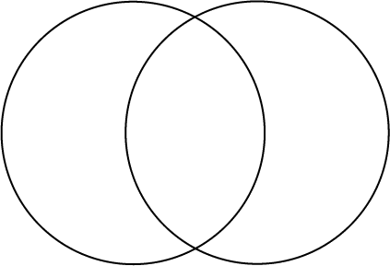
Vocabulary [3]  List and define each word:  Mesopotamia, surplus, civilization, city-state, ziggurat, polytheism, bronze, stylus, cuneiform, scribe, Hammurabi, code of law, and empire.  Write a paragraph using at least 5 of these words. | City States Poem/Song [5]  Write a poem or song about the city-states of Mesopotamia. It must include at least 10 rhyming lines discussing the following:  - Where they were located  - 3 city state names  - How they looked  - 2 leaders names | Ziggurat [2]  Label and describe the following parts of a ziggurat: The shrine (cella), platforms, and triple stairways.  Explain what the purpose of a ziggurat.  Be sure to include an image of a ziggurat.
Cuneiform [3]  - Define cuneiform, stylus, and scribe.  - Include an image of a cuneiform tablet.  - Create a chart that shows and defines 5 cuneiform pictographs.  - Write your name in cuneiform. | Mesopotamian Inventions [4]  Create a chart that describes at least three Mesopotamian inventions such as the plow, board games, and pottery. Be sure to include how they were used in the past and are used in the present. Include a picture of each invention. | Hammurabi’s Law Code [4]  In 3-5 sentences, explain what Hammurabi’s Code is.  Include 6-10 sample laws from his code.  Then, use those same laws to create your own punishments.

Magazine Rubric
_______________________

Requirement | Points Earned | Points Possible
Cover  Picture  Heading  Text box  Border |  | 10
Neatness & Design  Neatness  Effort  Format  Layout  Mostly typed |  | 15
Language Conventions  Spelling  Grammar  Fluency  Capitalization  Punctuation |  | 15
Information  Factual information  Details  Uses his/her own words  Explanations |  | 50
Point system  16 points or more |  | 10
Total & Score |  | 100

